COSC422 Assignment 2 Harry Dobbs

Task 2.1 – Animation of embedded motion data (6 Marks):
Brief Outline: I have implemented various methods to ensure the animation looks realistic. The main methods used include:
- Position Interpolation – The ArmyPilot.x animation is made up of rotation and position keys. Each of these keys correspond to a point in time. However sometimes the time might be between the time of position keys. This time can be use to work out an interpolated position between the two keys depedant on the time. An interpolated position vector will be generated and then used to generate the position matrix.
- Rotation Interpolation – This is a similar concept to position interpolation except instead of finding a position vector it will find a quaternion which is then used to generate the rotation matrix.
- Bone Weighting (3 Marks): An algorithm was implemented that allows for vertex blending. This works by associating the vertices with the neighboring bone matrices. This prevents weird unrealisitc disortion of the bones.
- View Frame Tracking – The animation has been programmed to happen at the origin. The camera can rotate around this point whilst zooming in and out this is done by altering the FOV parameter and preforming glRotatef() to the scene.
- A moving plane (1 Mark) was implementing to simulate movement of the model.
Problems:
- I had an Issue with the original rendering of the model being heavily distorted this was due to incorrect usage of the transpose method. I used the transpose method as a method that returned the tranposed matrix rather than one that applied it to the current matrix. This was solved by correctly understanding how the method works.

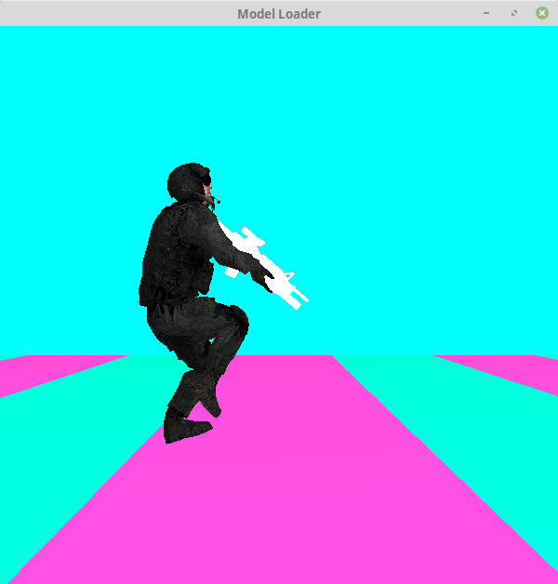Figure 1: Side on View of Army Pilot with Vertex Blending
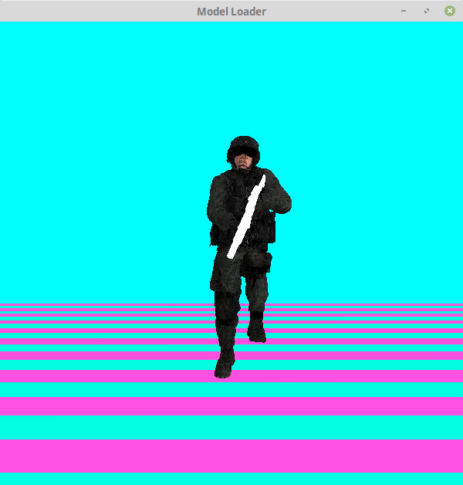Figure 2: Front on View of Army Pilot with Vertex Blending

Task 2.2 – Animation of rigged character model using a seperate motion file (6 Marks):
Brief Outline: This part of the assignment used much of the code from the first part of the assignment. The main methods included in this part of the assignment were:

A brief outline of the implemented methods, including any problems/challenges faced and how you attempted to solve them.
Please describe the methods used for positioning the model within the view frame and tracking it during motion.
Please also describe the processes used for animation retargetting. •
A screenshot of each animation. • The complete list of keyboard/mouse functions defined for user interaction. COSC422 Advanced Computer Graphics Assignment 2 3 • List of references to the sources of any additional materials (textures, mocap files, model files) used.

